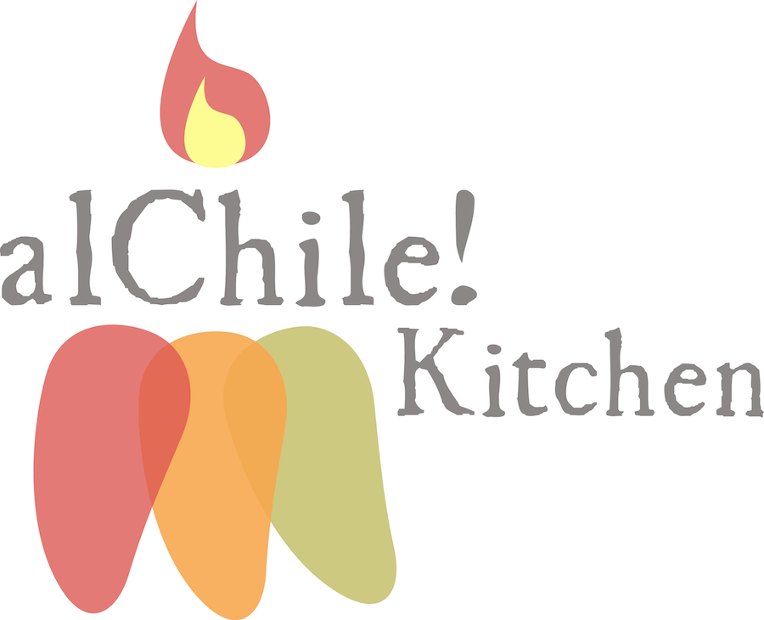

Breakfast:
(Vegan items available depending on location)

(V) Chia Pudding with Seasonal Fruit

Yogurt & Mix Fruit Salad

Eggs & Protein

Farm Simple Eggs

Bacon Strips & Turkey Sausage

Cheese & Deli Meat Platter

Toasts, Butter & Jams

Side Dishes

Protein Power Quinoa

Roasted Herbed Potatoes

Roasted Veggie Mix

Avocado Toasts & Toppings

Breakfast Wraps

Coffee & Juice Station

Mix of Pastries

Mini Quesadillas:
Cheese Only Blend

Chips & Salsas

Drinks: Agua Fresca Flavors

Hibiscus Flower
Horchata
Lime Cucumber
Pineapple Chia

